# **Process Monitoring:-**

**Step 1:** Verify on the host that the required process is being monitored by OneAgent.

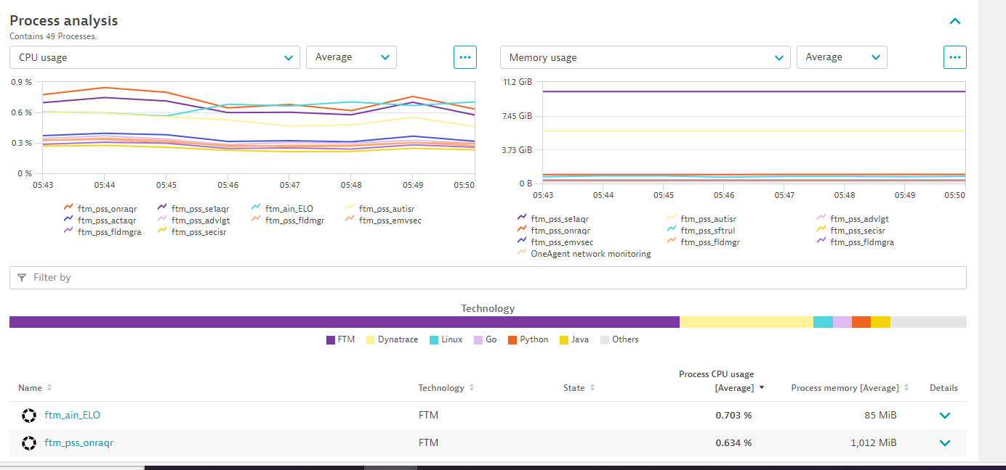

**Step 2:** If the required process is monitored by OneAgent and has a recognized technology, follow the steps below to create a Metric Event for alerting or If the technology is set to "other," proceed to **Step 3.**

1. Goto Settings as shown below: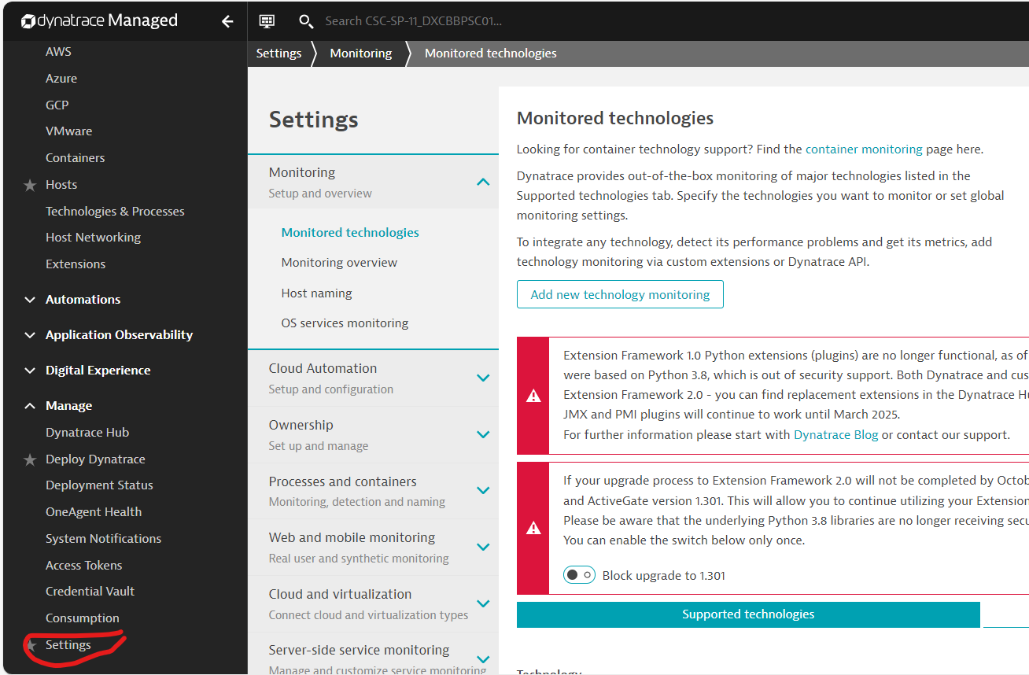
2. Goto Anomaly detection >Metric Event>Add metric event.

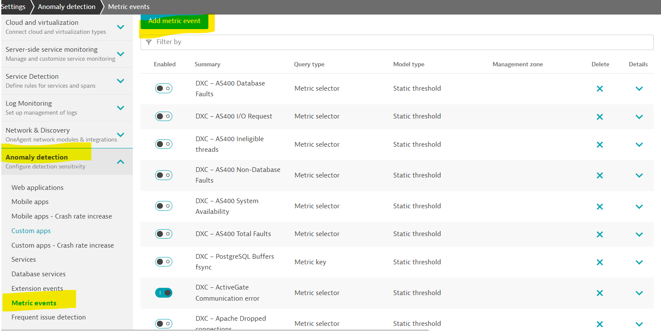

1. Refer to the metrics created for the FTM process. Based on these, you can either create a new metric or duplicate an existing metric and make the required changes.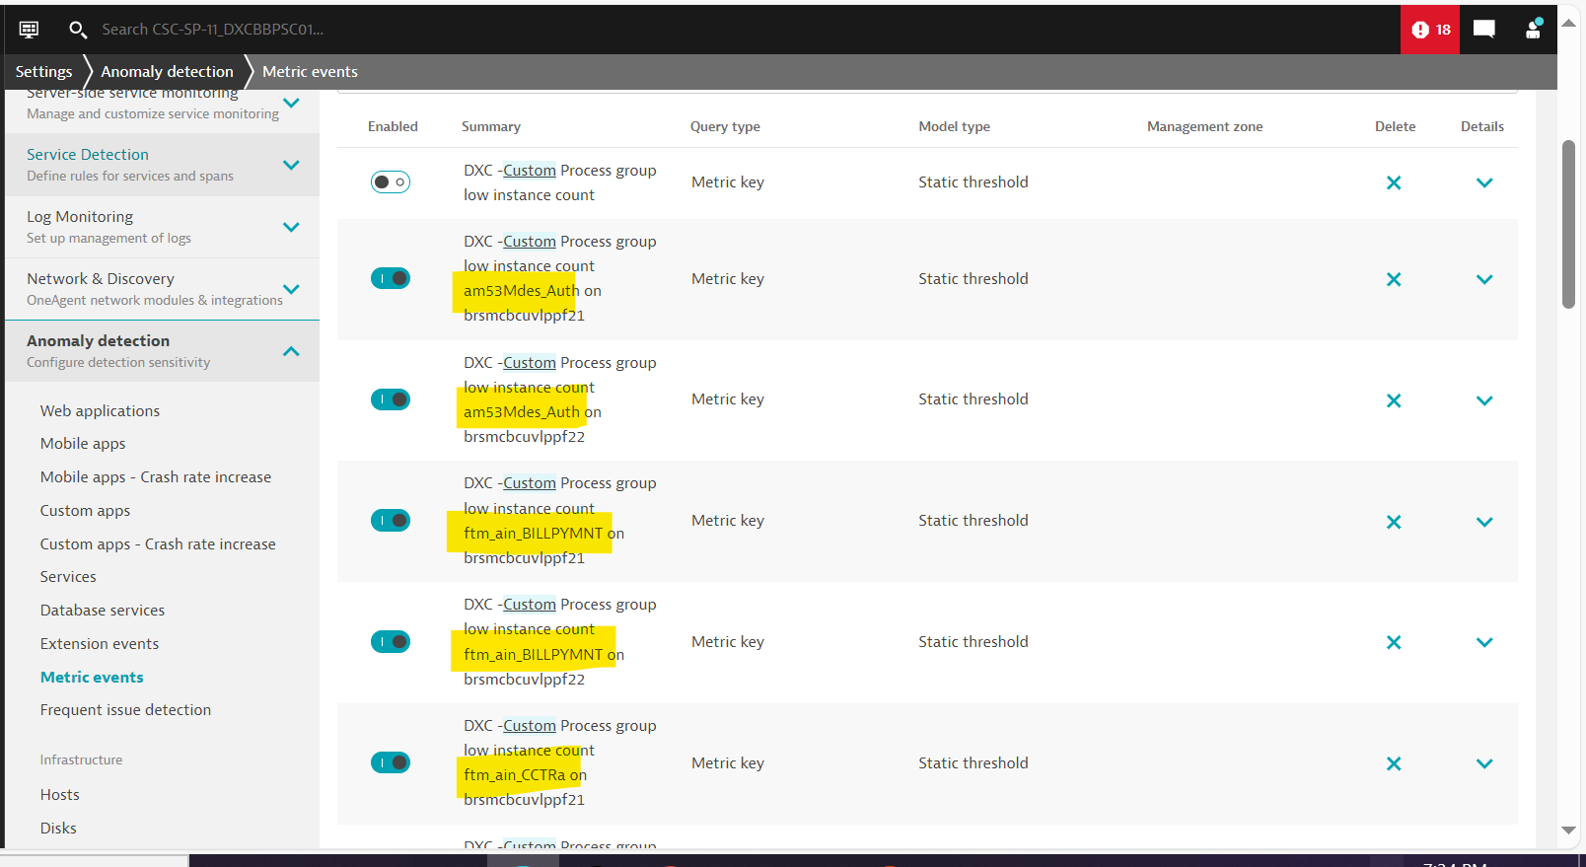

**Step 3:** If the technology is "Other," we need to declare the process technology. This ensures that OneAgent monitors the technology without interruptions. Follow the below process:

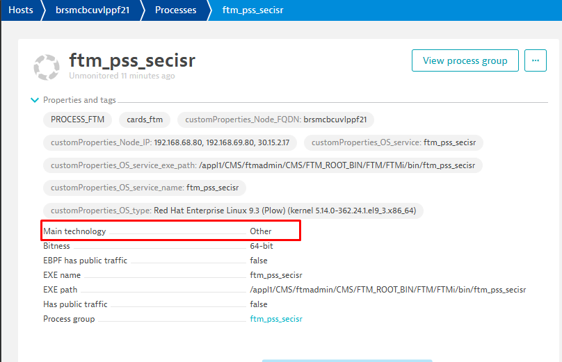

*Settings > Processes and containers > Declarative process grouping*. For instructions on how to set this up, please see the below documentation.  
<https://docs.dynatrace.com/docs/shortlink/process-groups#declare>.

1. Click on the Setting on the Host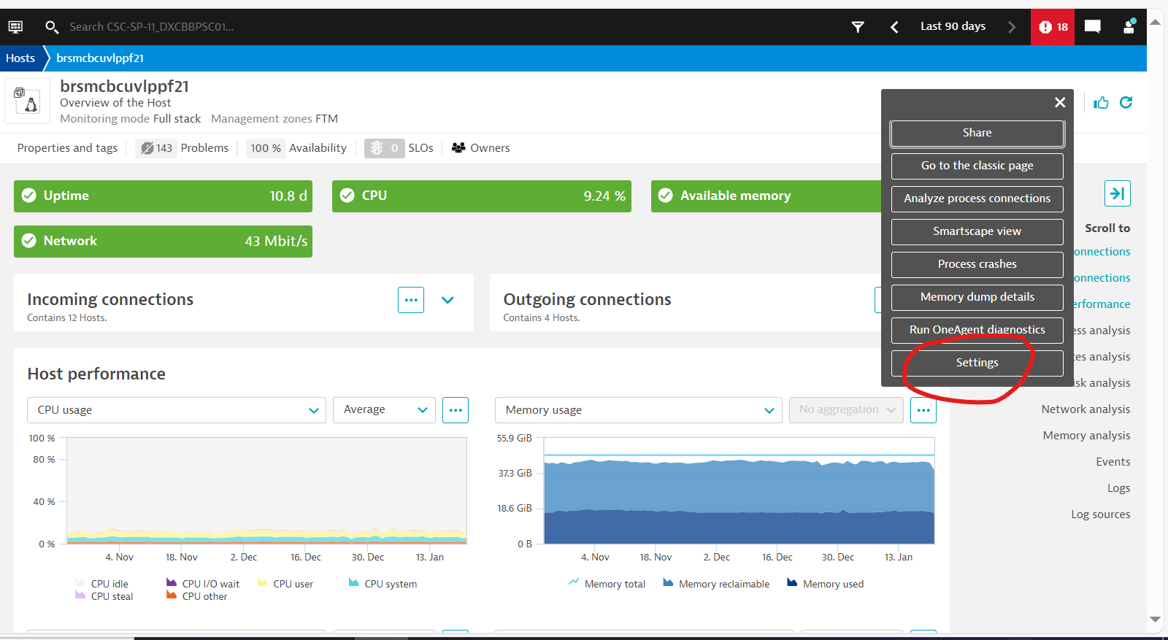
2. Click on Declarative process grouping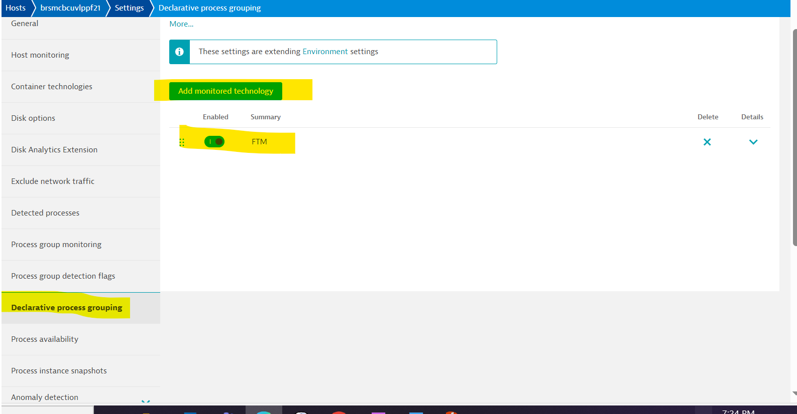
3. Add Monitoring Technology for that Process.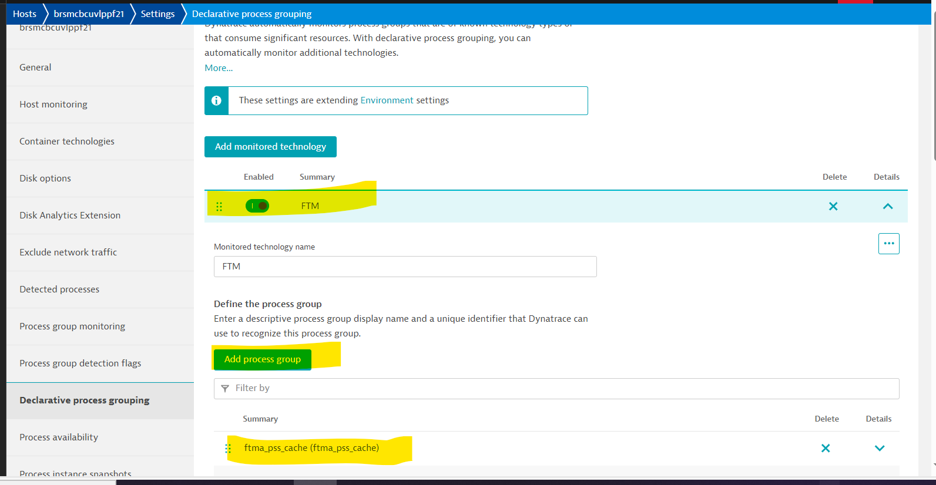

For more instructions use this <https://docs.dynatrace.com/docs/shortlink/process-groups#declare>.